- ReactJS-HOL

Create StudentApp React App with 3 Components

Step 1: Open VS Code and Create React App
  - Open VS Code
  - Open a new folder where you want to create your app.
  - Open the terminal in VS Code: Terminal → New Terminal
  - Run this command:
npx create-react-app studentapp

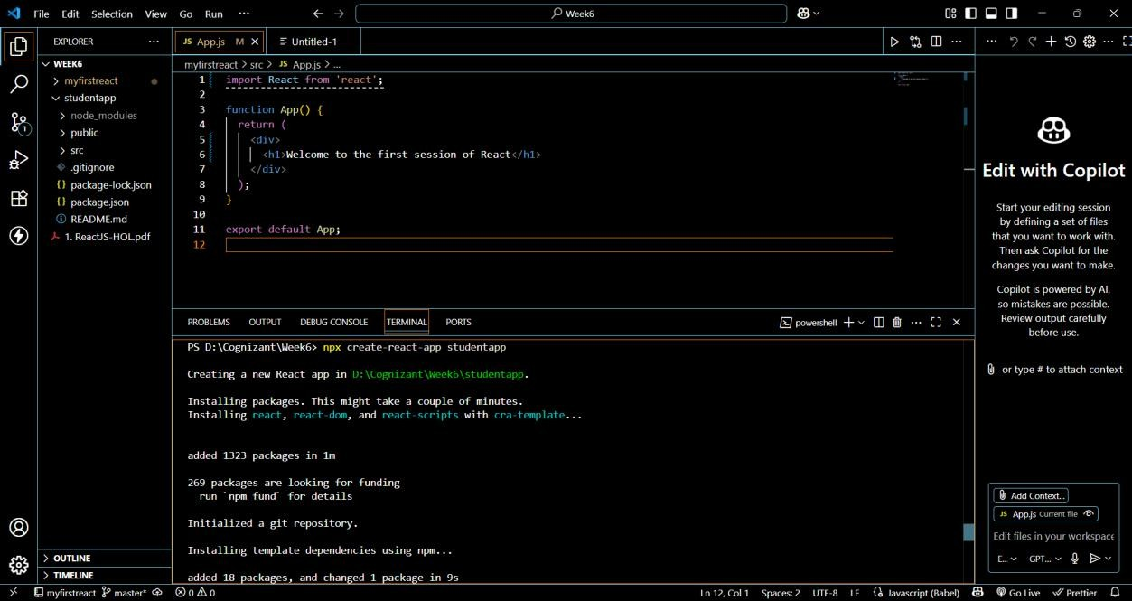

Step 2: Move Into the Project Folder
cd studentapp
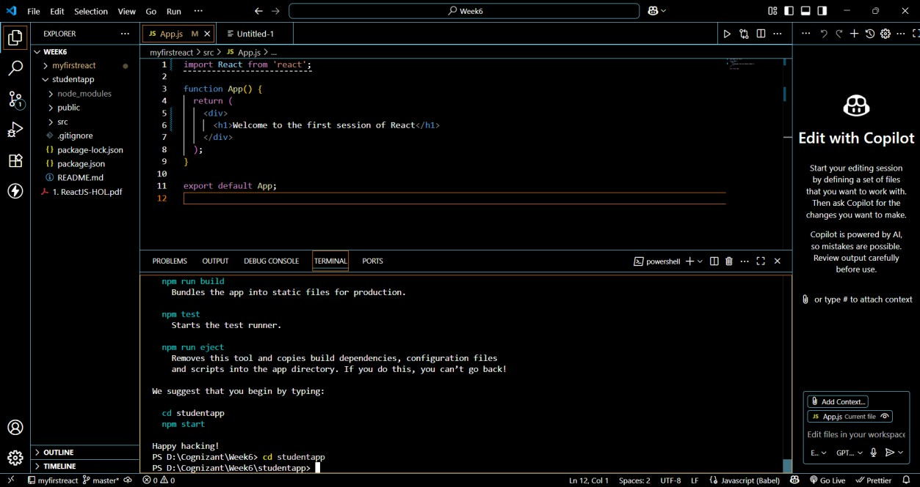

Step 3: Create a Folder for Components
In the src folder:
- Right-click → New Folder → Name it Components Step 4: Create Home.js Component (Class Component) In src/Components/Home.js, add:
import React, { Component } from 'react';
class Home extends Component { constructor(props) { super(props);
}

render() {
return <h2>Welcome to the Home page of Student Management Portal</h2>;
}
}

export default Home;

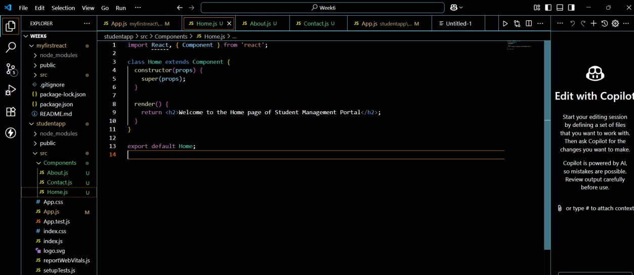

Step 5: Create About.js Component (Class Component)
In src/Components/About.js, add:
import React, { Component } from 'react';

class About extends Component { constructor(props) { super(props);
}
render() {
return <h2>Welcome to the About page of the Student Management Portal</h2>;
}
}
export default About;

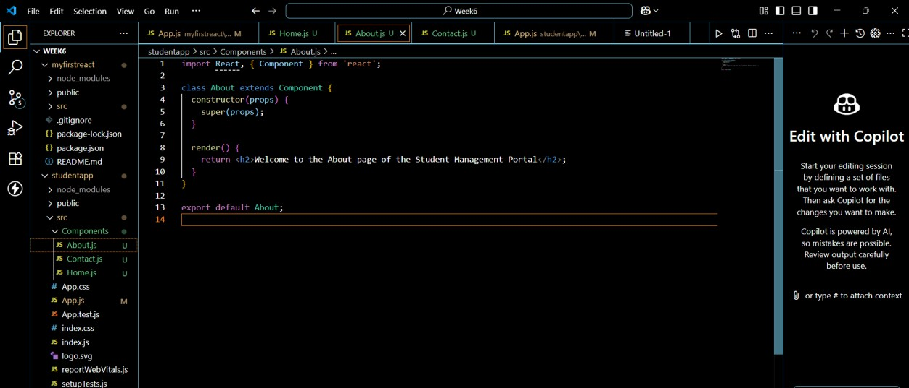

Step 6: Create Contact.js Component (Class Component)
In src/Components/Contact.js, add: import React, { Component } from 'react';
class Contact extends Component { constructor(props) {
super(props);
}
render() {
return <h2>Welcome to the Contact page of the Student Management Portal</h2>;
}
}

export default Contact;

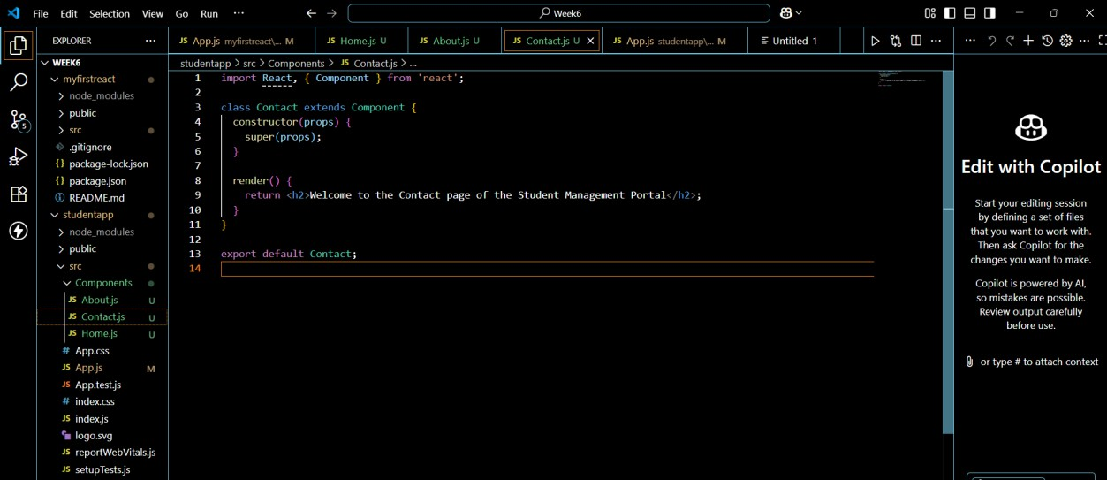

Step 7: Edit App.js to Use the Components
In src/App.js, replace everything with: import React from 'react';
import Home from './Components/Home';
import About from './Components/About'; import Contact from './Components/Contact';
function App() { return (
<div>
<h1>Student Management Portal</h1>
<Home />
<About />
<Contact />
</div>
);
}
export default App;

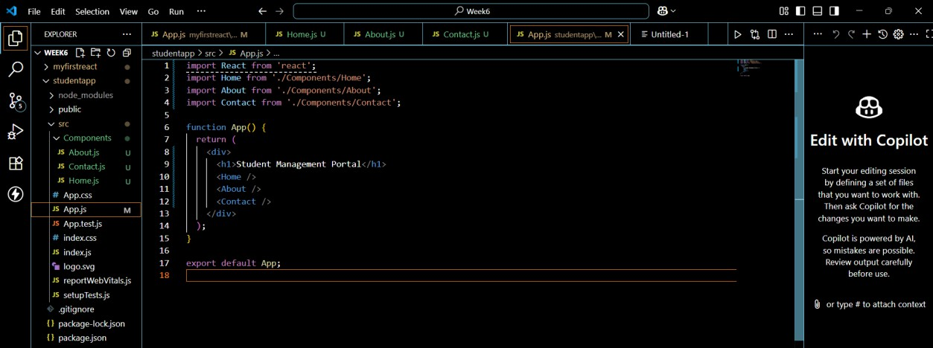

Step 8: Run the React App
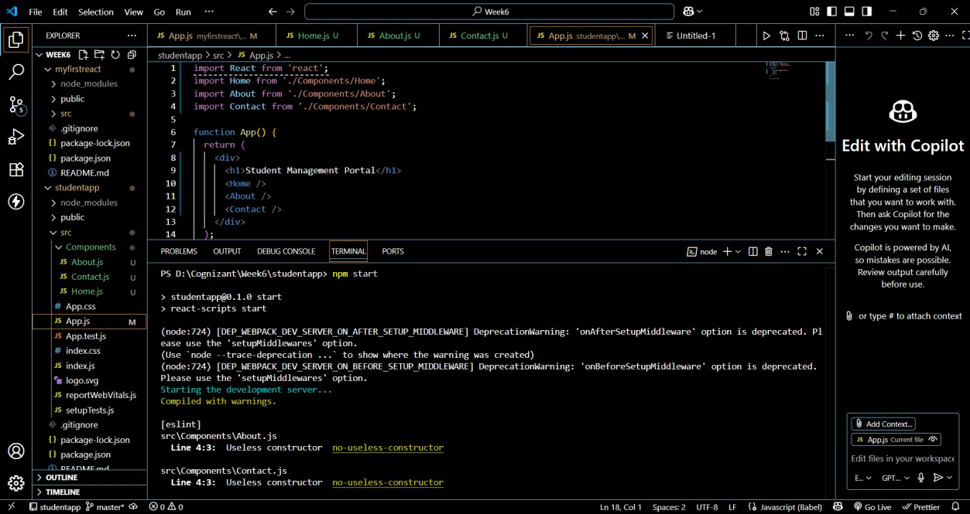
In the terminal, inside the StudentApp folder, run: npm start

Step 9: View Output in Browser Open a browser and visit: http://localhost:3000

You should see:
Student Management Portal
Welcome to the Home page of Student Management Portal Welcome to the About page of the Student Management Portal Welcome to the Contact page of the Student Management Portal

Result:
